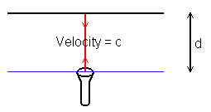
Worksheet 1
Meanwhile, over on the platform, Mr. Round Hat observes something a bit different. By the time the light has bounced back to the source, the source has travelled a distance ${uΔt}_{R}$, so the light has travelled further. Mr. Round Hat still observes the speed of light to be c, so perceives a longer round-trip time.
Equation 2

Use Pythagoras’ theorem to find the distance l in terms of d, u and delta_t_{R}.

l = __________________
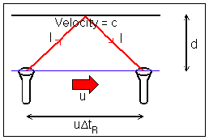
From his vantage point on the train, Mr. Flat Hat sees this. A simple calculation gives the round trip time ${Δt}_{F}$ (subscript F for Flat Hat!) (the time it takes for the light to go from the bottom mirror to the top one and back again). 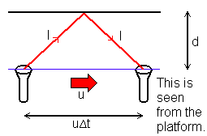
Equation 1

Round-trip time : ${Δt}_{F}$ = ______
Equation 3

Now, find the round-trip time as seen by Mr. Round Hat.

${Δt}_{R}=\frac{2l}{c}=$ ________________
Worksheet 1
Equation 4

Substitute Equation 1 into Equation 3 to get rid of d

${Δt}_{R}$ = ________________
Equation 5 : This is it!!!

Square both sides of Equation 4 and solve for ${Δt}_{R}$

${Δt}_{R}$= ________________
Notice that ${Δt}_{R}$is given by a number times ${Δt}_{F}$.
This number is called the gamma factor, as you will see elsewhere.
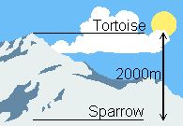
Worksheet 2
The mountain is 2000m high, and the muons take 6.5 microseconds (ie 6.5x10⁻⁶ seconds) to travel from the top to the bottom. They arrive at the top of the mountain at a rate of 563 per hour.
The muons have a halflife ($τ_{\frac{1}{2}}$) of 1.5 microseconds, equivalent to a lifetime ($τ_{\frac{1}{e}}$) of 2.16 microseconds.
The difference between the halflife and the lifetime is that after one halflife, ½ of the muons will have decayed, whereas after one lifetime, ¹/_{e} of the muons will remain. It is easier to work in lifetimes, as calculators are fitted with e and ln buttons!
Part 1

Think before you stick the numbers in!!

- Should the rate of arrival at the bottom of the mountain be larger or smaller than the rate at the top?
- How much larger or smaller?
- How many muons would be left if the muons took 2.16 microseconds to make the journey? What if they took 4.32 microseconds?

‘Expected’ rate at bottom of mountain = _____ x e ___________
Parts 2 & 3

The sparrow actually observes 413 muons per hour at the bottom of the mountain.

- Hint : Remember that you have a ln button on your calculator!
- Calculate the ‘actual’ lifetime in the muons’ frame of reference, then compare this with the ‘expected’ lifetime to find the gamma factor.
- Will the muons perceive the mountain to be taller or shorter?

Rate = _____ = e ______________
therefore
ln _____ = _____/______
and
gamma = _______
so
Height in muons’ reference frame = __________

The mountain is 2000m high, and the muons take 6.7 microseconds (ie 6.7x10⁻⁶ seconds) to travel from the top to the bottom. They arrive at the top of the mountain at a rate of 563 per hour.
The muons have a halflife ($τ_{\frac{1}{2}}$) of 1.5 microseconds, equivalent to a lifetime ($τ_{\frac{1}{e}}$) of 2.16 microseconds.
Worksheet 3
Part 1

In order to calculate the K⁰'s lifetime in its own inertial frame, we first need to find its gamma factor, and its lifetime in our inertial frame.

Insert the velocity of the K⁰ in the equation you solved on Worksheet 1 to find its gamma factor.

$γ$ = ___________________

By clicking on the K⁰, you should have found out some information about it. As it is travelling so rapidly (note its velocity!) it is subject to relativistic effects such as time dilation (as were the muons coming down the mountain).
Part 2

Now, use the velocity and the length of the K⁰'s track to find its lifetime in our inertial frame.

- Hint : Don’t be scared – you probably first came across this equation in primary school!!

Lab lifetime = ___________

Part 3

Finally, use the gamma factor to find its lifetime in its own inertial frame (i.e. its lifetime when it is at rest.

- Hint : Above all, think about it!! Will the K⁰’s rest lifetime be longer or shorter than the measured lifetime in the lab?

Rest lifetime = ___________________

