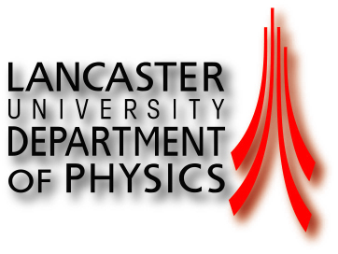
Lancaster Particle Physics

by Dr Richard Lee, Dr Frank Foster and Prof. Terry Sloan
Lancaster University.

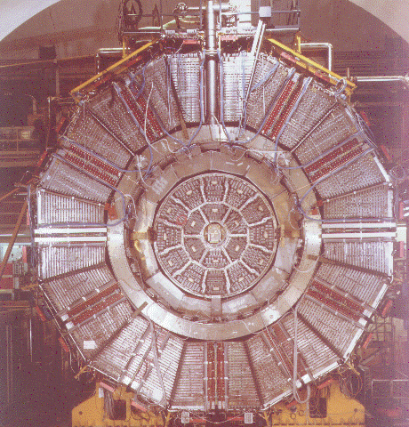
End view of the ALEPH detector with the end plate removed, CERN, Geneva.

